**Python File I/O**

Python file operations : opening a file, reading from it, writing into it, closing it.

File is a named location on disk to store related information. It is used to permanently store data in a non-volatile memory (e.g. hard disk).

**Example:**

f = open('secrets.txt')

secret_data = f.read()

# secret_data is a string

f.close()

**Opening A File**

f = open('secrets.txt')

# OR

f = open("C:/Python33/secrets.txt") # specifying full path

When we open a file we specify whether we want to read 'r', write 'w' or append 'a' to the file.

*Syntax*

file_object = open(file_name, access_mode)

* **file_name** : the name of a file including its path.
* **access_mode** : an optional parameter which decides the purpose of opening a file, e.g. read, write, append

**Writing A File**

By default, the open() function will only allow us to read the file. We need to pass the argument 'w' to write over the file

# Add a second argument to the function, 'w' which stands for write.

# Passing 'w+' lets us read and write to the file

f = open('secrets.txt','w+')

Opening a file with 'w' or 'w+' truncates the original, meaning that anything that was in the original file **is deleted**!

# Write to the file

f.write('This is a new line')

**Appending To A File**

Passing the argument 'a' opens the file and puts the pointer at the end, so anything written is appended. Like 'w+', 'a+' lets us read and write to a file. If the file does not exist, one will be created.

f = open('secrets.txt','a+')

f.write('\nThis is text being appended to test.txt')

f.write('\nAnd another line here.')

**Closing A File**

When we are done with operations to the file, we need to properly close the file.

Closing a file will free up the resources that were tied with the file and is done using Python close() method.

f = open('secrets.txt')

f.close()

This method is not entirely safe. If an exception occurs when we are performing some operation with the file, the code exits without closing the file.

A safer way is to use a try…finally block.

try:

f = open("secrets.txt",encoding = 'utf-8')

# perform file operations

finally:

f.close()

This way, we are guaranteed that the file is properly closed even if an exception is raised, causing program flow to stop.

The best way to do this is using the with statement. This ensures that the file is closed when the block inside with is exited.

We don’t need to explicitly call the close() method. It is done internally.

with open("secrets.txt",encoding = 'utf-8') as f:

# perform file operations

# Out of the with : the file is closed

# f.closed is True

**Example:**

f = open('output.txt', 'w')

for i in range(10):

f.write("this is line: %i\n"%i)

f.close()

# Same as

with open('output.txt', 'w') as f:

for i in range(10):

f.write("this is line: %i\n"%i)

**Iterating Through A File**

for line in open('secrets.txt'):

print(line)

**Common Methods**

f.read()

f.readline() # Reads one entire line from the file. Reads a file till the newline

f.readlines() # Reads a file line by line, returns a list of the lines in the file

f.write(str)

f.writelines(seq) # Writes a list of lines to the file.

# Example :

# lines=["Hello world.\n", "Welcome to Tel Aviv.\n"]

# f.writelines(lines)

f.seek(offset)

f.tell() # for binary files, mostly

f.close()

We can change our current file cursor (position) using the seek() method. Similarly, the tell() method returns our current position (in number of bytes).

>>> f.tell() # get the current file position

56

>>> f.seek(0) # bring file cursor to initial position

0

>>> f.seek(6) # bring file cursor to the 6th position

# If the file contains "Hello World", the cursor will start at "W"

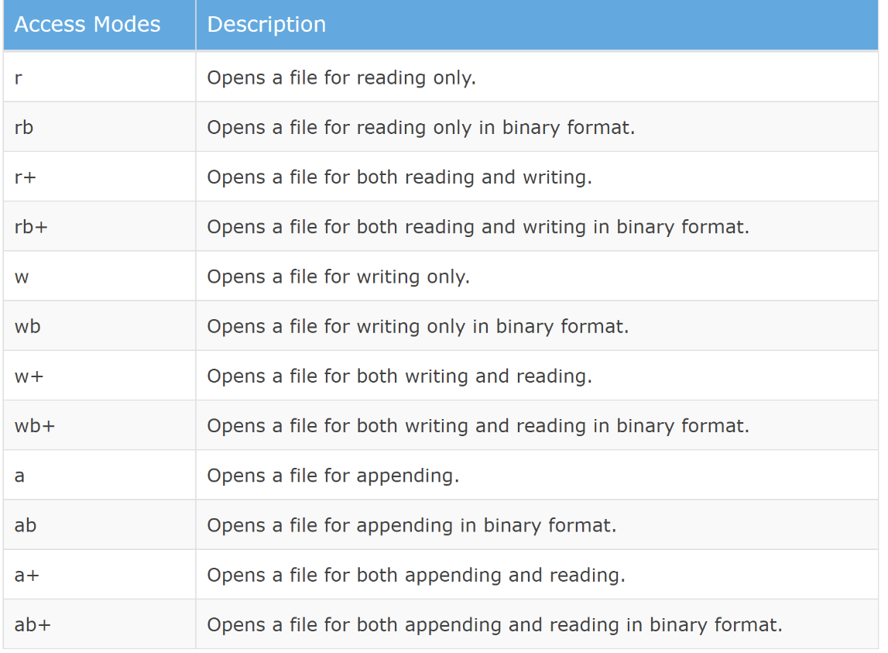

**Exercise**

Download this text file http://www.practicepython.org/assets/nameslist.txt and do the following steps

* Read the file line by line
* Read only the 5th line of the file
* Read only the 5th first characters of the file
* Read all the file and return it as a list of strings. Then split each word
* Find out how many occurences of the names "Darth", "Luke" and "Lea" are in the file
* Append your first name at the end of the file
* Append "SkyWalker" next to each first name "Luke"